SAVE THE DATE!
April 1 – District 2 4-H Junior Leader Lab Registration Opens on 4-H Online! (Details below)
April 10 – District 2 4-H Spring Workshop (details coming soon)
April 13 – Spring 4-H Club Meeting at 6:00 (Event Center)
May 2 – District Indoor Archery Contest in Plainview (deadline to register on 4-H online is 4/15)
May 27-29 – Junior Leader Lab (Plains Baptist Camp, Floydada) – Youth that have completed 3rd-7th grade are eligible to attend; $250; registration will open April 1 (watch for details soon!)
June 2-5 – Texas 4-H Roundup in College Station
June 11-13 – POWER Camp (Plains Baptist Camp, Floydada) – Youth that have completed 8th-12th grade are eligible to attend; $185; registration will open April 21 (watch for details soon!)
July 31-August 1 – Wicker Ranch 125th Anniversary Celebration (4-H will sponsor a concession during the roping event on Saturday, 8/1)

DEADLINES TO REMEMBER:
March 18 – District 2 deadline to apply for Texas 4-H Congress
March 23 – County deadline for Photography contest
March 30 – County deadline to enter Fashion Show, Duds to Dazzle, Educational Presentation, Public Speaking or Talent Showcase
April 1 – Steer, Heifer and State Fair Lamb/Goat/Swine Tag order deadline to Julie (all tags are $25 each)
April 15 – County deadline to register for District 2 4-H Indoor Archery Contest on 5/2

PROJECT INFORMATION:

- District 4-H Fashion Show and Duds to Dazzle contests will be Monday, April 20th in Lubbock. County deadline to participate in either contest is Monday, March 30th. [Contest information: Fashion Show is an individual contest https://d24-h.tamu.edu/fashion-show/ and Duds to Dazzle team of 3-4 contest info https://d24-h.tamu.edu/duds-to-dazzle/]

- District 4-H Educational Presentation/Public Speaking and Talent Showcase contests will be Monday, April 27th in Floydada. County deadline to participate in any of these contests is Monday, March 30th. Contest information can be found: https://d24-h.tamu.edu/district-roundup/. Please let Julie know if you have any questions or need help in deciding if this contest is for you.

- Robotics Project – if you are interested in learning about robotics, please let Julie know – we will start meeting in early April!

- 4-H Archery Project – practices have started! Contact Julie or Coach Penny Cribbs if you would like to participate. District Indoor Archery Contest is Saturday, May 2nd in Plainview.

- Youth interested in Livestock, Meat or Horse Judging, please let Julie know by March 18th.

DETAILED INFORMATION INCLUDED IN THIS EMAIL BELOW:
- 4-H Photography Project – see details below – County Contest Deadline is Monday, March 23rd.

- Texas 4-H Congress (see info below and letter attached) ***Deadline to apply is 3/18***

- District 2 4-H Junior Leader Lab (May 27-29, Floydada) – details below

- Texas Tech Livestock and Meat Judging Camps (flyer and info below)

- Youth Range Workshop (flyer and info below)

- Hands Helping Heroes, the 2026 Texas 4-H Council Community Service Project Challenge

4-H Photographers! Please be preparing your photos for the County Contest which has a deadline of March 23rd!

4-H Photography Contest

Please be preparing your photos for the County Contest which has a deadline of March 23rd!
Guidelines for the District 2 4-H Contest can be found here: https://d24-h.tamu.edu/files/2026/02/2026-Photography-Letter.pdf
State guidelines for Senior age participants can be found here: https://texas4-h.tamu.edu/wp-content/uploads/photography_state_contest_2025_2026.pdf
Please submit entries HERE by midnight on Monday, March 23rd.
https://forms.gle/YswejC9ZcATdLEjo8

Texas 4-H Congress
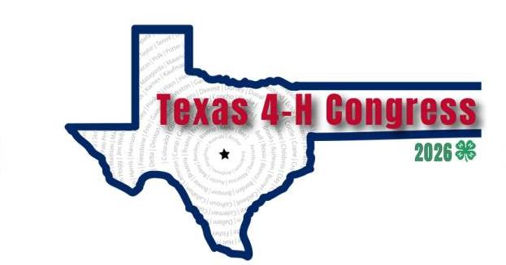

For youth entering 9th or just graduated this Summer. This is an amazing opportunity to see first hand how our Texas government process works and make some amazing friends from across the state!

You must submit this first to be considered to apply – deadline March 18th (deadline date change).
https://docs.google.com/forms/d/e/1FAIpQLSfiy4XX68nsAIDBkxQLEpwD3zcysLrqQVGHNUDD7nkdoPddZw/viewform

Additional information in the attached letter.

DISTRICT 2 4-H JUNIOR LEADER LAB

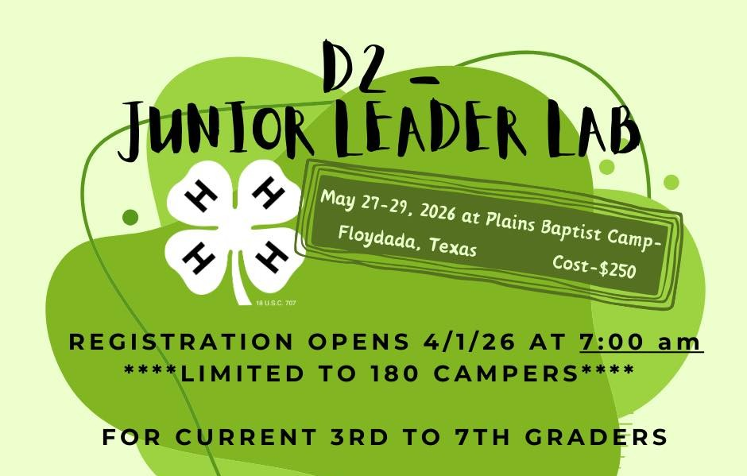

https://d24-h.tamu.edu/junior-leader-lab/
May 27-29 at Plains Baptist Assembly in Floydada
For youth that just completed 3rd-7th grades
$250
Registration opens on 4-H Online at 7:00 a.m. on Wednesday, April 1! This camp has a history of filling up within the first hour, so do not delay in registering.
Youth must be enrolled in 4-H to register.
*Julie will be attending as an agent chaperone.

TEXAS TECH JUDGING CAMPS & FEARLESS CHAMPIONS JUDGING SHOOTOUT REGISTRATION FORMS ARE OPEN
Please see the flyers and forms for all camp details.
Livestock & Shootout hotel block information is in the registration links.
Meat Judging Camp hotel blocks are pasted below. Reservations must be made at least 3 weeks prior to the camp you are attending.
We can't wait to have each student in the Department!
LIVESTOCK CAMP REGISTRATION: https://forms.office.com/r/kVvXCxwT1D
SHOOTOUT REGISTRATION: https://forms.office.com/r/UE5vJJrPRP
MEAT CAMP 1: https://forms.office.com/r/jYvX9h9dXW
MEAT CAMP 2: https://forms.office.com/r/Ey1weHJuag
MEAT JUNIOR CAMP: https://forms.office.com/r/Gt2yV22LQg
MEAT JUDGING HOTEL BLOCKS:
Comfort Suites Camp 1: https://www.choicehotels.com/reservations/groups/TO91T6
Days Inn Camp 1: https://www.wyndhamhotels.com/hotels/50253?checkInDate=05/28/2026&checkOutDate=05/30/2026&groupCode=TTMJC
Comfort Suites Camp 2: https://www.choicehotels.com/reservations/groups/OU12H1
Days Inn Camp 2: https://www.wyndhamhotels.com/hotels/50253?checkInDate=06/12/2026&checkOutDate=06/14/2026&groupCode=TTMJC2

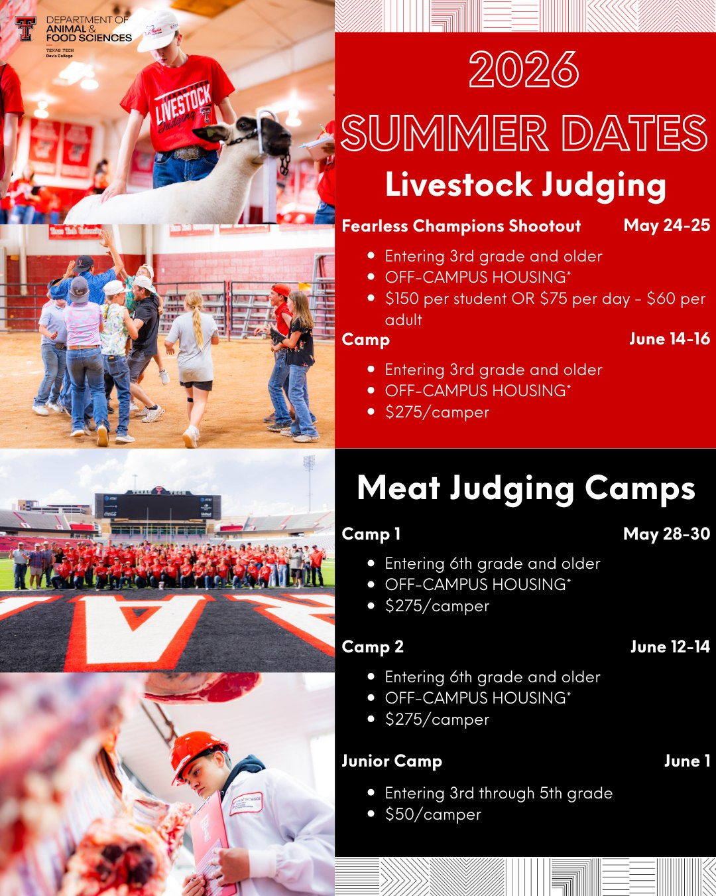

Youth Range Workshop

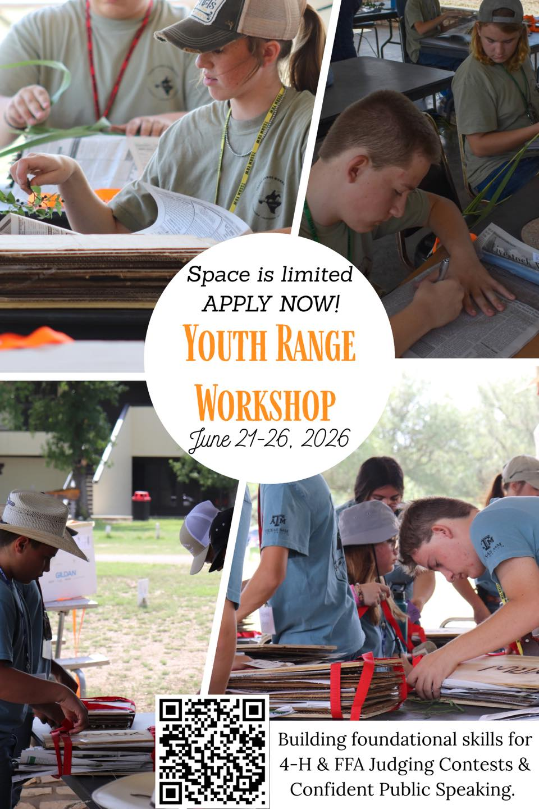

Calling all future Range Riders, Plant Gurus, and Competition Champions!
Are you ready to explore the fascinating world of plant collections? Join us at the Youth Range Workshop from June 21–26, 2026, where our unique curriculum includes an engaging Plant Press Collection activity!
But what exactly is a plant press collection? It's a hands-on project where students learn to meticulously press and preserve plant specimens. This process not only involves identifying various plant species and their characteristics but also mastering the art of labeling them accurately.
Guided by our expert instructors, students will develop essential skills in creating the 'perfect pressed specimen.' These skills are invaluable for success in 4-H and FFA judging contests.
Don't miss this opportunity to be part of an enriching experience that goes beyond plant collections to provide a competitive edge for future endeavors. Spaces are limited, so act fast!
For more information, scan the QR code in the graphic or leave your questions in the comments. We can’t wait to welcome the next generation of plant enthusiasts and champions—could it be you? Apply today!
June 21–26, 2026
Ages 14–18
Texas Tech University Junction Campus
APPLY NOW: https://tinyurl.com/yrw2026

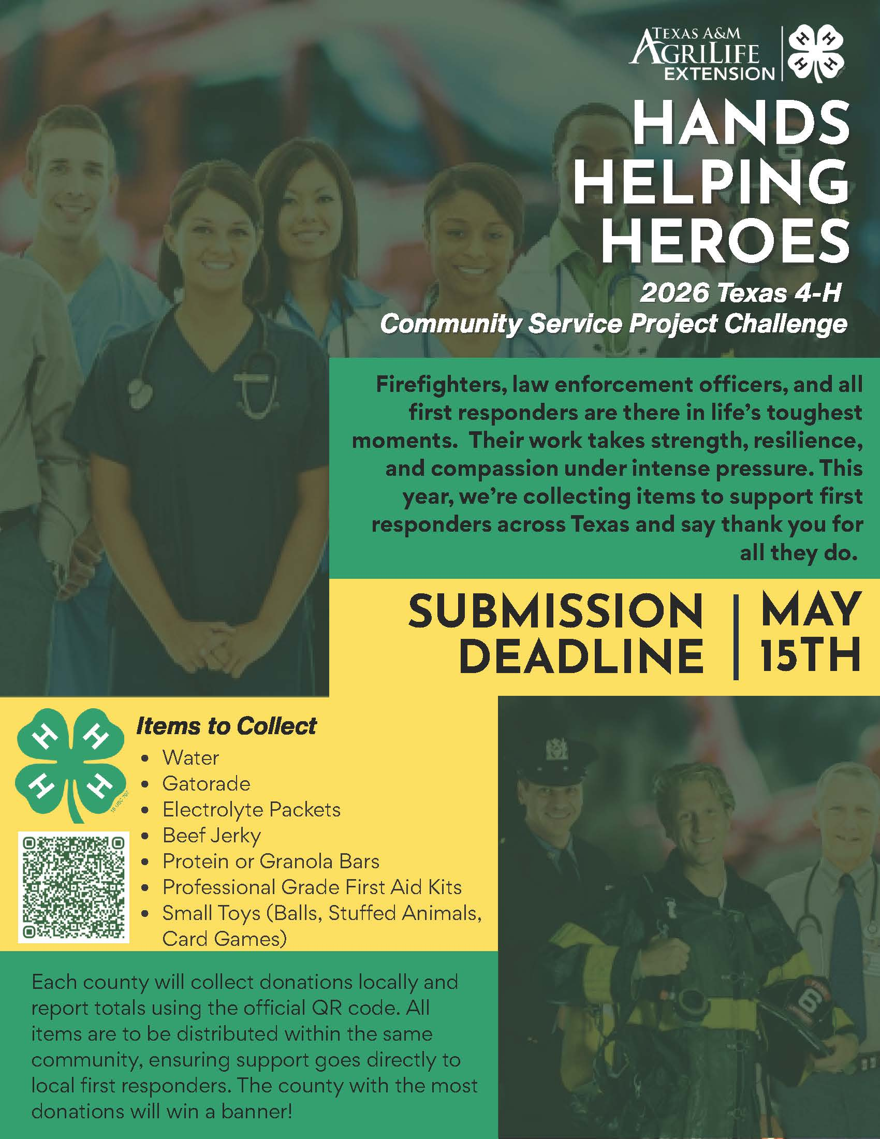

Texas 4-H Council wants to invite you to join them in Hands Helping Heroes, the 2026 Texas 4-H Council Community Service Project Challenge. Firefighters, law enforcement officers, paramedics, EMTs, emergency dispatchers, and all first responders are there in life’s toughest moments. Their work takes strength, resilience, and compassion under intense pressure.

This year, we’re encouraging you to collect items to support first responders across Texas to say "thank you" for all they do. We are asking counties and clubs to collect the following:
- Water
- Gatorade
- Electrolyte packets
- Beef jerky
- Protein or granola bars
- Professional grade first aid kits
- Small toys (balls, stuffed animals, or card games).
Each county will collect donations locally; there is no state collection for this project. All items are to be distributed within the same community, ensuring support goes directly to local first responders. The entire project is completed locally, with the exception of reporting your donations. You may bring your items to the Extension office or make plans to bring to our Spring 4-H Club meeting on 4/13.

Are you signed up for our Band App? Get reminders and updates and see a calendar of events.

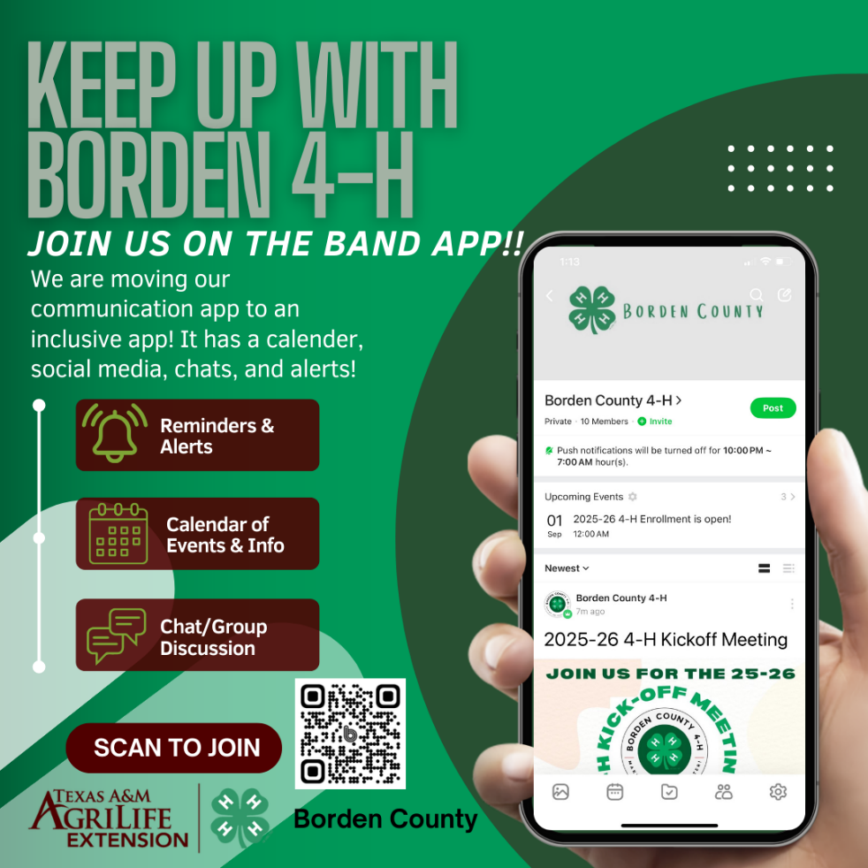

Julie Mumme Smith
County Extension Agent-Family and Community Health

Texas A&M AgriLIfe Extension Service
Borden County
140 East Wilbourn
P.O. Box 155
Gail, TX 79738
(806)756-4336 office
(806)773-7388 cell
(806)756-4486 fax
jm-smith@ag.tamu.edu
http://borden.agrilife.org
Facebook: Borden County Extension and 4-H

